Pizza Sales SQL Query and Output

- Total Revenue
- select sum(total_price) as total_revenue from pizza_sales

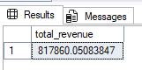

- Average order value
- select sum(total_price) / count(distinct order_id) as avg_order_value from pizza_sales

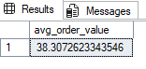
- total pizza sold
- select sum(quantity) as total_pizza_sold from pizza_sales

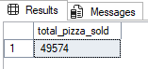

- total orders
- select count(distinct order_id) as total_order from pizza_sales

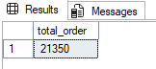

- average pizza per order
- select sum(quantity) / count(distinct order_id) as avg_pizza_per_order from pizza_sales

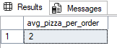

NOTE : use cast to get decimal value

- select cast(cast(sum(quantity) as decimal(10,2)) / cast(count(distinct order_id) as decimal(10,2)) as decimal(10,2))as avg_pizza_per_order from pizza_sales

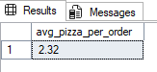

- Daily trend for total orders
- select datename(dw, order_date) as order_day, count(distinct order_id) as total_orders from pizza_sales
group by datename(dw, order_date)

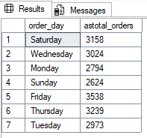

- monthly trend for total orders
- select DATENAME(month,order_date) as months_name, count(distinct order_id) as total_order from pizza_sales
group by DATENAME(month,order_date)
order by(total_order) desc

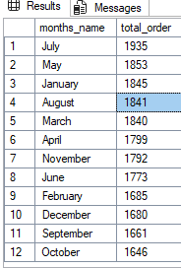

- percentage of sale (pizza category wise)
- select pizza_category, sum(total_price) * 100 / (select sum(total_price) from pizza_sales) as PCT from pizza_sales
group by pizza_category
order by PCT desc
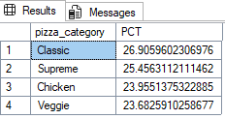

NOTE : To check the sales for a particular month

select pizza_category, sum(total_price) * 100 / (select sum(total_price) from pizza_sales) as PCT from pizza_sales
where month(order_date) = 1
group by pizza_category

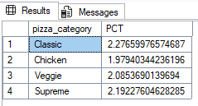

- percentage of sales by pizza size
- select pizza_size, sum(total_price) * 100 / (select sum(total_price) from pizza_sales) as PCT_size from pizza_sales
group by pizza_size

NOTE : using cast to limit decimal

- select pizza_size, cast(sum(total_price) * 100 / (select sum(total_price) from pizza_sales) as decimal(10,2)) as PCT_size from pizza_sales
group by pizza_size

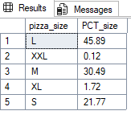

NOTE : to see quarter wise sales
select pizza_size,sum(total_price) as total_sales, cast(sum(total_price) * 100 / (select sum(total_price) from pizza_sales) as decimal(10,2)) as PCT_size from pizza_sales
where DATEPART(quarter, order_date) = 1
group by pizza_size
order by PCT_size asc

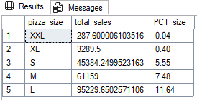

- Top 5 pizza by revenue
- select top 5 pizza_name, sum(total_price) as total_revenue from pizza_sales
group by pizza_name
order by total_revenue desc
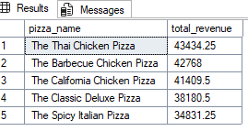

- Bottom 5 pizza by revenue
- select top 5 pizza_name, sum(total_price) as total_revenue from pizza_sales
group by pizza_name
order by total_revenue asc

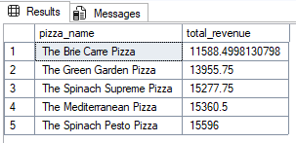

- Top 5 pizza by quantity
- select top 5 pizza_name , sum(quantity) as total_quantity from pizza_sales
group by pizza_name
order by total_quantity desc

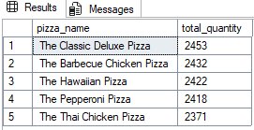

- Bottom 5 pizza by quantity
- select top 5 pizza_name , sum(quantity) as total_quantity from pizza_sales
group by pizza_name
order by total_quantity asc

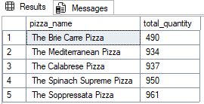

- Top 5 pizza by orders
- select top 5 pizza_name, count(distinct order_id) as toal_order from pizza_sales
group by pizza_name
order by toal_order desc

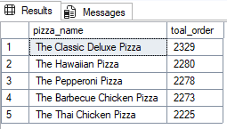

- Bottom 5 pizza by order
- select top 5 pizza_name, count(distinct order_id) as toal_order from pizza_sales
group by pizza_name
order by toal_order asc

